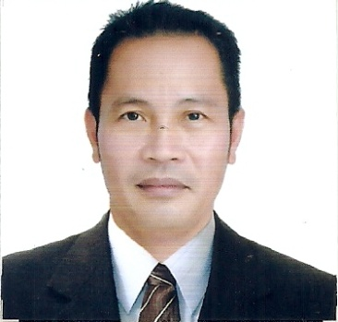

Abelardo Labe
------------------------------------
CURRICULUM VITAE

Address: Block 1 Lot 17
Joshua Street
Northcrest Village
Bagumbong Caloocan, Philippines

Tel: (63) 2 405 4710
Mobile: (63) 21 9 613516344
E-mail: labeabelardo@yahoo.com
Health: Excellent

Personal Statement
I am currently the owner operator of a local taxi business incorporated in 2010. I am a hard working individual with excellent business and interpersonal skills. I am an honest, loyal, hardworking person and I feel I have much to offer any prospective employer.

Skills:

Experience in animal husbandry.
Knowledge in welding.
Familiar with engine maintenance.
Experienced in Commercial building - labourer

Work History:

Passenger Transport owner operator - Philippines
November 2010 - Present

- Pick up passengers and drop them off to the destination.
- Vehicle maintenance.

Dump truck driver, Almobty Company, construction sites, Kingdom of Saudi Arabia
2008 - 2010

- Transportation of soil, gravel, sand for civil engineering projects.
- Heavy vehicle for road work construction.
Self employed -Transport business, Philippines
2001 - 2007

- Passengers service Manila.
- Vehicle maintenance.

Mini school bus driver - Maezapa Public Transport, Caloocan - Philippines
1995 - 2000

- Responsible for picking up students to and from home- School.
- Vehicle maintenance.

Filler Operator- American Beverage Corporation, Canlubang Laguna - Philippines
1990 - 1994

- Responsible for quality control.

Education and Training

Secondary School Pamplona Municipal High School (1989)
- Diploma
Dairy Training & Research Institute, Philippines (2005)
- Certificate

INTERESTS/HOBBIES:

- Gardening
- Chess
- Basketball
- Breeding animals

CHARACTER REFERENCES:
Lea Niña Alonzo - Friend
Block 1 Lot17 Northcrest Village Bagumbong Caloocan City Philippines
Ph: (63)9275972400

Marisa Diwa - Neighbor
Block1 Lot17 Northcrest Village Bagumbong Caloocan City Philippines
Ph: (63) 9062348919

Bonifacio Himpisow - Friend
Sampaloc Bagumbong Caloocan City Philippines
Ph: (63) 9081239637

