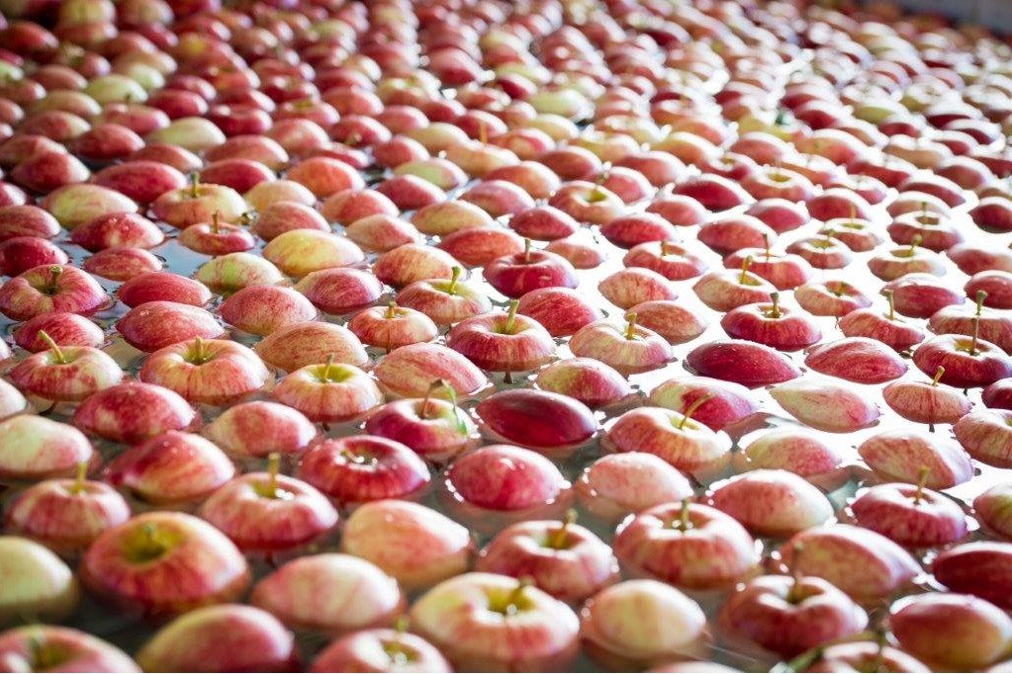
1

Postharvest

Handbook
CAJ Van Der Voort Ltd
33 Moa FlatRoad, Ettrick RD2 2020 Edition

NEW ZEAL AND APPLES

Table of Contents
KEY PACKHOUSE CONTACTS 7
CAJ HISTORY 8
Preamble 8
Key Dates 8
CAJ ORCHARDS & PACKHOUSE LOCATION 9
NOW 10
Innovation 10
THE OWNER 11
Con van der Voort 11
THE ORCHARD MANAGEMENT TEAM 11
Chris Hull – Operations Manager & Southern Orchard Manager 11
John McKinnel – Dumbarton Orchard Manager 12
John Tomkin – Nithdale & Fruitvale Orchard Manager 12
Ross Smith – Elderslea & Dunrock Orchard Manager 12
Hayden Taylor – Roseburn Orchard Manager 13
Murray Booth – Hollandia & Earnscleugh Orchard Manager 13
THE PACKHOUSE TEAM 13
Toni Birtles 13
Jackie van der Voort 13
Carla O’Connor 14
Leandro Massariolo (Lea) 14
Richie Waters 14
THE PACKHOUSE & VARIETIES WE PACK 15
The Packhouse Operation in Brief 15
Apple Varieties 15
THE INDUSTRY 16
NZ Apple Industry Leads the World 16
HEALTH & SAFETY 17
Emergency Response 17
First Aiders: 17
Assembly Points: 17
Packhouse Map 18
Fire Extinguishers 19
Site Hazards 20
Site Hazard Map 20
Unsafe Equipment 21
Protective Equipment & Safety Devices: 21
Footwear 21
Hearing Protection 21
Protective Clothing 21
Event Reporting 22
Operating Plant & Equipment 22
Four rules for operating a machine 22
Electrical Equipment 22
Communication & Consultation 23
Health & Safety Forum 23
QUALITY & FOOD SAFETY 24
Hygiene 24
Personal Hygiene 24
Hand Washing 24
CONTAMINATION OF FRUIT 24
Foreign Matter 24
Glass, Plastic & Metal 24
Wood & Leaf 24
Eating & Drinking 25
Allergens 25
Blood & Bodily Fluids 25
WASTE 25
SECURITY 25
Cameras 25

2 3

HEALTH 26
Sickness & Ill health 26
Infectious Diseases 26
Medical Conditions 26

FACILITIES 26
Toilets 26
Smoke Free & Smoking Designated Areas 26
Unauthorised Areas 27

PROFESSIONAL & PERSONAL DEVELOPMENT 27
People & Performance 27
Health & Safety Policy 27
Continuous Improvement Policy 27
Alcohol, illegal drugs & solvents Policy 27
Harassment (sexual or racial) Policy 27
Domestic Violence 27
Punctuality 27
Payday 28
Product Removal 28
Complaints & Suggestions 28
Resignations 28
Disputes & Personal Grievances 28

Key Packhouse Contacts
The Post-Harvest Manager is:
Jackie van der Voort Ph: 021431689

The Health, Safety & Compliance Manager is:
Carla O’Connor Ph: 027 236 5085

Packing Supervisor is:

Packing Team Leaders are:
R
KellyKelly
Tray Filler Team leader is:

Your First Aider is:

Quality & Phytosanitary Team
Supervisor is:

OTHER CONTACT NUMBERS 28 | Phytosanitary Inspectors are:
APPENDIX 29
APPENDIX ONE – HEALTH & SAFETY POLICY 29
APPENDIX TWO – DRUGS AND ALCOHOL POLICY 31 | Cosmetic/Defect & Reject Analysis Inspectors are;
APPENDIX THREE– HARASSMENT POLICY 32
APPENDIX FOUR – QUALITY & FOOD SAFETY POLICY 34
APPENDIX FIVE– GLASS & PLASTIC POLICY 35
APPENDIX SIX – BLOOD & BODILY FLUIDS POLICY ......................... 36 NOTE
APPENDIX SEVEN - BLOOD & BODILY FLUIDS EVENT FORM ............. 37 This handbook is designed to give the employee a general overview
APPENDIX EIGHT - CAJ-FR-11-002 Event Report Form .................... 38 of the policies and procedures within CAJ. If you need/want more
RECOGNISED SEASONAL WORKERS SIGN OFF............................. 41 information please speak with your supervisor, or manager.

EMPLOYEE SIGNOFF 42

4

CAJ HISTORY

Preamble
In 1952 when Cornelius (Con) Adrianus Josephus van der Voort was 23 years of age he immigrated to New Zealand from the Netherlands. He immediately started work in Lawrence as the Hospital Gardener and it was here that he met Eileen Goodlet who he would later marry. After working at the hospital and then for Eileen’s father who owned the local garage, Con ventured into fruit growing.
It was in 1960 when Con and Eileen moved to Ettrick to run the 23ha apple orchard known as Nithdale Orchard. Con’s background as a market gardener helped, however he had no apple growing experience. Eileen didn’t have any previous horticulture experience either. Con thanks his neighbours for educating him at this early stage in his career.
The van der Voort operation has grown over the years under Con’s leadership, now being an operation of around 400 ha’s, with 300 ha’s of this planted in apple trees.
Con is a strong believer in family and today, daughters Toni and Jackie are heavily involved in the operation. While Toni takes charge of administration, finance and employment, Jackie manages the packing facility. The operation has experienced several challenges, alongside the normal industry challenges of frost and hail, to having a fire rip through the pack house in 2000, just as the harvest season started.
Con has always personally been involved in all aspects of the apple growing industry including several years as a Director on the NZ Apple and Pear Board. In 2012 Con was a recipient of the Bledisloe Cup, this is the industry’s highest recognition and honour. At the NZ Apples & Pears Conference in 2019, Con was presented with the New Zealand award for Outstanding Contribution to the pip fruit industry.
Recently the van der Voorts have completed a significant project to update the existing facilities.
5
Key Dates
1960 Purchased Nithdale Orchard and Packhouse and started pip fruit growing
1965 C A J purchased Fruitvale Apple Orchard

1977 Loose fruit submission to NZAP Marketing Board

1983 Developed an apple orchard in Earnscleugh – Hollandia Orchard 1985 Purchased Southern Orchards, apple orchard
1988 Started packing in a new Pack House facility on Moa Flat Road 1990 Developed an apple orchard at Dumbarton – Dumbarton Orchard 1994 Purchased two mixed Orchards
– Roseburn Orchard & Remarkable Orchards 2000 Packing shed burnt down
2001 Rebuilt packing shed on existing site and commenced packing 2009 Purchased a mixed orchard at Dumbarton – Elderslea
2010 Shed Extension to include stacking platform and strapping machine
2011 Upgraded 4 lane Sizer to 6 lanes

2012 Purchased a mixed orchard in Dumbarton - Dunrock

2016 Purchased bare land in Earnscleugh for orchard development 2016 Stage 1 shed development – staff amenities
2018 Stage 2 shed development – shed and canopy extension and new infeed canopy
2019 Stage 3 Installation & commissioning of new plant & equipment

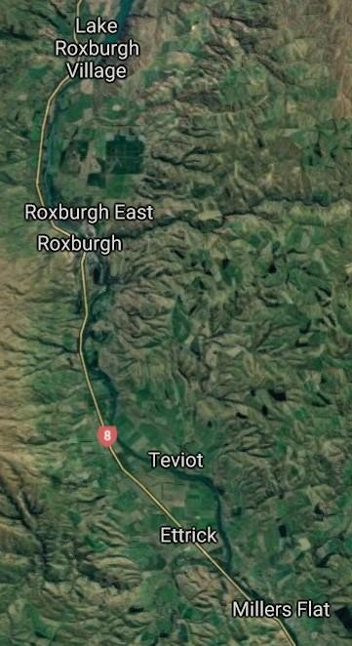
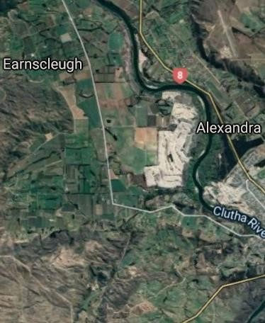
Earnscleugh
Southern
Remarkable
Roseburn
Hollandia
Elderslea

Dumbarton
Nithdale
Packhouse
Innovation
From 2018 the Packhouse has been undergoing an upgrade. This is a four- stage development. This strategy started when we decided to look for a new defect sorter technology and quickly realised a combination of this and additional equipment would allow the packing shed to increase capacity.
We had new plantings within existing blocks which were coming on stream and new land purchased for orchard development, which all pointed to a substantial increase in our production.
Stage one of the project was to upgrade the staff amenities. We extended the staff room, locker rooms and additional bathrooms and hand wash area.
The second stage was to extend the shed and canopy. This is now enclosed and ensures we meet market phytosanitary requirements.
The third stage was to upgrade all plant, equipment and infrastructure and by doing this we brought state -of-the-art systems to Central Otago. This enabled the business to meet the NZ Food Act 2017 and BRC compliance requirements. A new ceiling to reduce the loss of heat through existing skylights and improved lighting, has also been installed.
In addition, a new 14 lane GEOsmart defect and sizer system (Greefa) was installed with the capability to produce 2500 cartons per hour, an increase in production of 60%. Greefa have provided a new infeed system integrated with the CR automation high pressure apple wash system and brush bed. This is state-of-the-art equipment designed and developed in New Zealand. Inside the packhouse, Greefa have integrated with Hayden & Custance, another New Zealand company fabricating and installing world class equipment, for an empty and full box carton system.
We are using the latest Quality System from Greefa, which allows us to distinguish between different defects and means we run with no human

8 9

sorting before the sizer, the staff who were previously grading fruit have been moved into other roles in the packhouse and we are working smarter and more efficiently.
The fourth stage will be automation of palletisation, which will come in 2021. CAJ van der Voort and Greefa’s focus is aligned, and we are both concentrating our efforts to gain excellence in fruit handling with importance on efficiencies in the most fruit friendly manner.
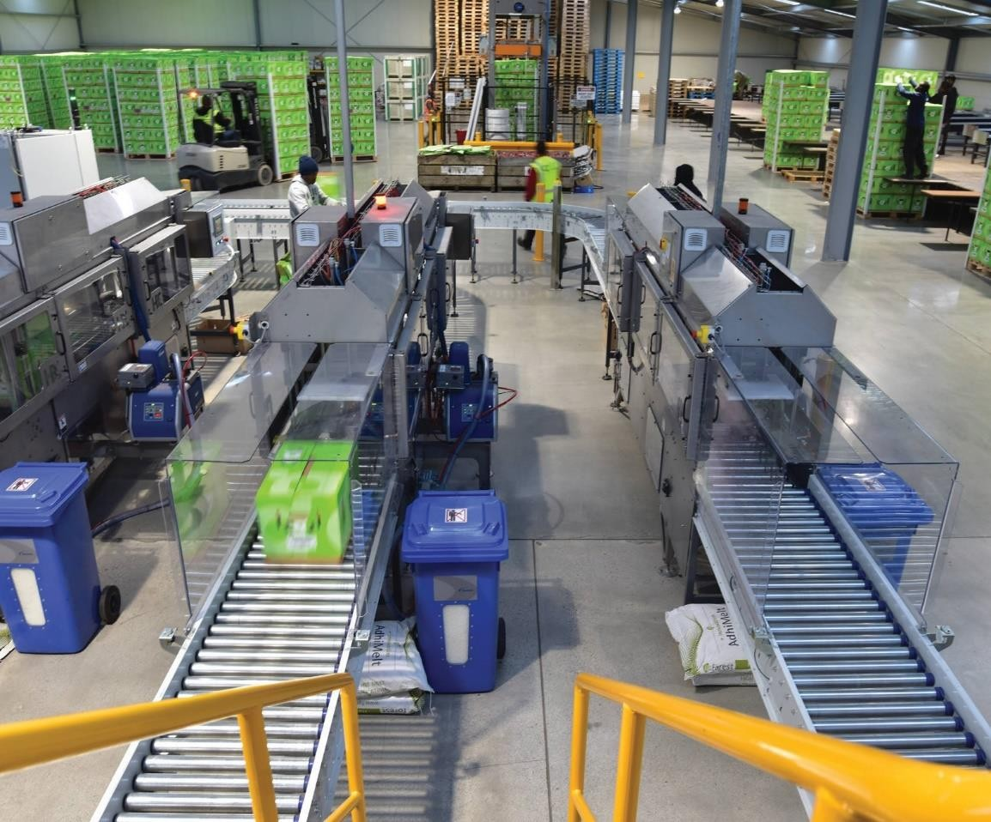
The upgraded facility was officially opened in 2019, with a guided tour of the facilities showing all the great innovation that’s happening in Ettrick to the local community, service providers, customers, and key contractors.
Con van der Voort – Owner
Con purchased his first orchard (Nithdale) in 1960. He had a background in market gardening and had minimal knowledge of growing apples. With perseverance and hard work Con has continued to acquire, invest in land and packhouse innovation, and as a result CAJ has grown from strength to strength. CAJ’s is one of Central Otago’s best kept secret success stories.
Con is still very much part of the business, keeping a hand in the growing and packing and exporting of apples.

11

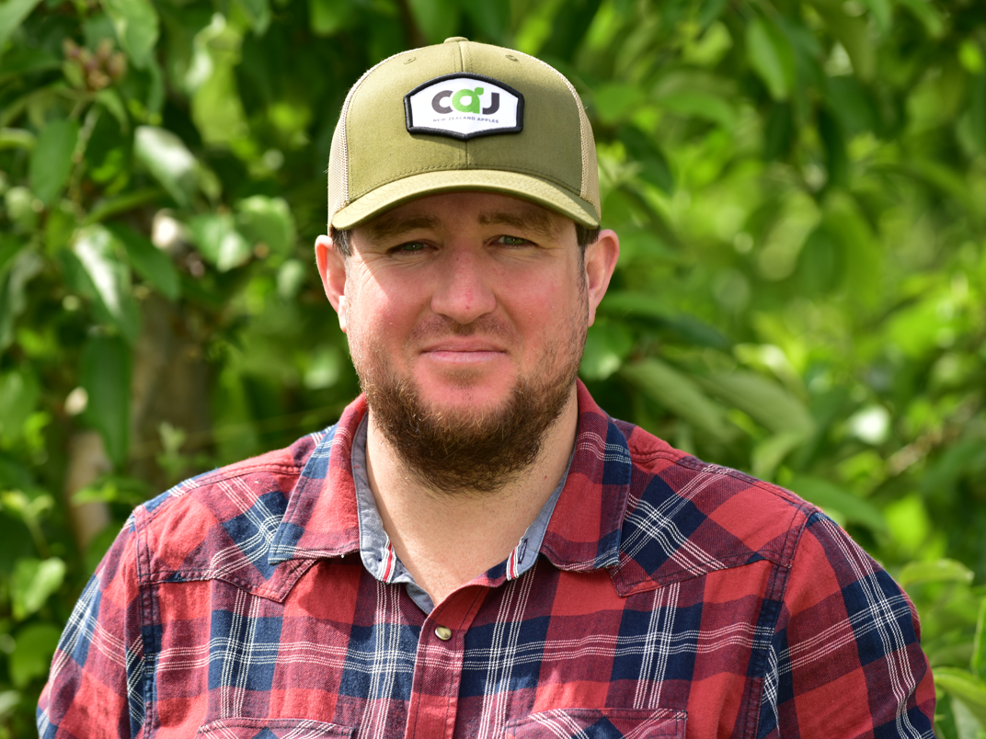

THE ORCHARD MANAGEMENT TEAM

CAJ employs 6 Orchard Managers. Collectively they have over 150 years’ experience with CAJ. Although managed in the same way each orchard has its own nuances in regard to micro-climates and soil types. Each Orchard Manager is responsible for getting the best crop return from the orchard, and meeting on orchard market compliance requirements. Orchard activities involve pruning, thinning, frost fighting, orchard maintenance, pest control (including spraying), employee management, new plantings, soil and water management and harvest.
Hayden Taylor - Roseburn Orchard Manager
Murray Booth – Hollandia & Earnscleugh Orchard Manager
All activities are conducted to ensure a successful harvest.

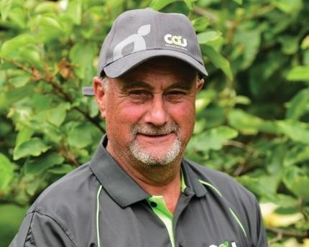
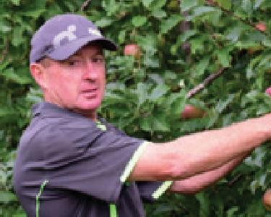
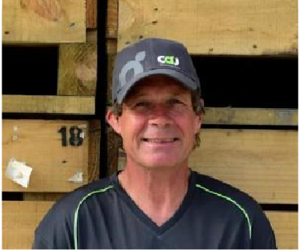
REMARKABLE ORCHARD
Chris Hull - Operations & Southern Orchard Manager
John McKinnel – Dumbarton Orchard Manager
John Tomkin – Nithdale Orchard Manager
Ross Smith – Elderslea Orchard Manager
12
CAJ is also part owner with Sid Birtles of the Remarkable Orchards.

Remarkable is a mixed fruit orchard growing both stone and pip fruit located in East Roxburgh.

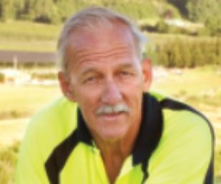

Sid Birtles - Owner/Manager

13

The Packhouse Team

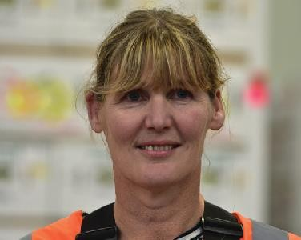
Jackie van der Voort Post-Harvest Manager
A member of the van der Voort family Jackie has grown up in the horticultural industry. Jackie is now the Post-Harvest Manager and is responsible for the fruit once it has been harvested, until it reaches our customers.

Toni Birtles
Finance & Administration Manager

Also, a member of the van der Voort family Toni is the Finance & Administration Manager. She has been working in the business since 1990 and as seen a lot of changes over the years, she enjoys seeing new people coming into the area every season and her responsibilities include payroll, employment, general administration and finance.

.

Leandro Massariolo (Lea) Dispatch Systems Coordinator

Lee joined the business in 2006 as a back packer from Brazil. He liked it so much he decided to stay. He is now responsible for the palletisation and dispatch of product to T&G Dunedin. Lee is also the ABC software systems guru.

Carla O’Connor
Health Safety
& Product Compliance Manager

Carla joined the business in 2019 and has over 20 years in the food industry with experience in both Health & Food Safety. Carla is responsible for making sure the business meets all its compliance requirements. Carla is originally from Canterbury and now spends her time between the Teviot Valley and Southland.

Richard (Richie) Waters Engineer
Richie also joined the business in 2019. Richie joined CAJ from the timber industry in Southland, moving to the Teviot Valley. Richie has responsibilities for the maintenance of plant & equipment for the Packhouse and Orchards.

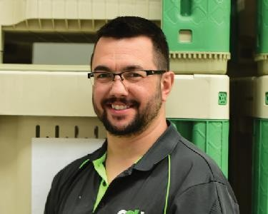
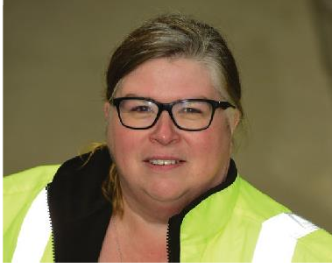

14 15

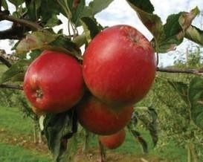
Varieties
Cox’s Orange - red fleck with yellow background
Pacific Queen - a large bi-coloured apple with red blush
Jazz - bright red
Pacific Rose - rose pink Royal Gala - red stripes Fuji - soft pink red
to bright red in colour. over yellow background blush or stripes – yellow Medium to large size background
Braeburn - reddish
Red Delicous -red with Granny Smith - bright a white flesh green skin that is often
speckled with faint white lenticels
Bright red with vibrant, glossy skin, they are juicy with deliciously sweet, bright white flesh
Koru apples are sweet, juicy, taste of vanilla and spice and pack a big crunch!

The packhouse operation in brief:

The CAJ Packhouse operates for 3-4 months (March to June) each year packing apples from all over Central Otago. The packhouse is designed to pack approximately 2500 TCE’s (Boxes) an hour. Each box contains on average 18kg of apples.
The Packhouse “calls up” or orders apples from the T&G coolstore where the apples are stored from the orchard before packing, they are delivered by truck to the CAJ yard, where they are scanned into the system and loaded into the Apple Dump. The apples are gently floated out of the bins into the apple wash system. The bins are then returned to the orchard for reuse.
Each apple is washed and sanitised before entering the packhouse where it is photographed for defects (defect sorter) and then weighed (by the sizer) and then sent to the required packing outlet (lane). This is where the automation ends, and apples are inspected and placed on the trays and boxed by hand.
The finished box then travels on a conveyor down to where it is weighed, then proceeds to box closing where an insert is placed in the box and the box is glued closed. From this point the box is scanned and delivered by conveyor to the palletisation area, where the boxes are palletised, strapped and labelled before final sign off and release for pickup and delivery to our customer.

16

NZ Apple Industry Leads the World
The World Apple Review has for the fourth year running named New Zealand’s apple industry the most competitive on the global stage, against 33 major apple growing countries.
The US based world fruit market analysts, the World Apple Review, stated that the innovations emerging from New Zealand’s apple industry will increasingly impact production and marketing throughout the world.
New Zealand’s high productivity gains helped deliver the outstanding performance, ahead of its closest rivals Chile and the United States.
Being named the best in the world is a huge honour and signaled the major significance New Zealand has on shaping and leading the industry on the world stage.
The world leading ranking comes as a huge reward to New Zealand’s
$850 million apple industry. This also recognises the efforts of the thousands of Kiwis working across the sector.
To earn and then retain this world leading title year on year is an outstanding achievement, and rewards everyone who is part of New Zealand’s exciting and dynamic apple industry.
This is an incredibly exciting time for our apple industry, together we are growing great people and the best apples for the world.
Our world leading achievements reflect New Zealand’s apple industry’s ongoing investment and commitment to leading and adopting greater innovation, research and development, new technologies, and environmental and social sustainability.
The World Apple Review highlighted that given New Zealand’s relatively small size, export orientation and distance from major markets, the industry had long relied heavily on innovation to provide it with a competitive edge.
It had been the leader in popularising Gala and Fuji, pioneered the first true club variety Jazz®, developed and produced a stream of new varieties Pacific Rose®, Envy®, Smitten® and Koru®.
In ranking the 33 countries, the World Apple Review compares production efficiency, infrastructure and inputs, and financial and market data. New Zealand was the best performer when all three rankings were combined.
According to the World Apple Review, over the past two seasons, New Zealand’s top performance, through exploiting new growing strategies and technologies produced over two and half times the average yield per hectare compared with the rest of world’s apple growing countries.
In general, off-season exporting countries like New Zealand had been forced to continually upgrade production systems to meet growing demands from the Northern Hemisphere.
For almost three decades, much of the innovation in apple varieties has emanated from New Zealand as the country has sought to offset its geographic disadvantage in accessing world markets.
The report stated that probably the single, most significant measure of innovation in a country’s orchards is the percentage of new varieties in production. It specifically highlighted how New Zealand was still actively searching for newer apple varieties to remain ahead of the field.
The bottom line on competitiveness, is that it is a moving target - continually moving upwards.
The apple industry needs to always monitor how the competitive bar is shifting and needs to be willing and able to adapt rapidly so they do not lose out in the competitive race, the report stated.

18 19

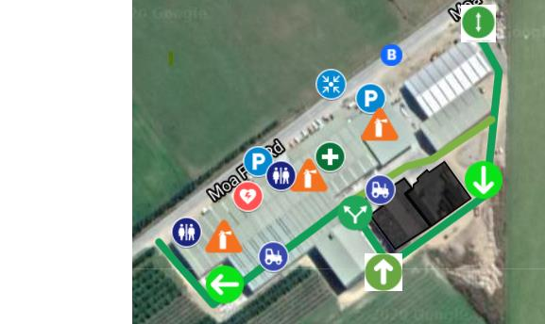
20
KEY
ARROWS – Traffic flow Direction
AED
TRACTOR – Forklift and Truck Areas
VEHICLE PARKING
FIRE EXTINGUISHER
TOILETS
FIRST AID STATION ……….
EMERGENCY EVACUATION POINT

Emergency Response
In any emergency you need to remain calm so that you can best:

- Prevent further injury or damage.
- Assist, as much as possible, anyone in distress.
- Get appropriate assistance.

IN THE EVENT OF AN INCIDENT REQUIRING EMERGENCY SERVICES
- USE A MOBILE PHONE, if practical to do so or
- THE NEAREST TELEPHONE LOCATED AT SITE OFFICE.
DIAL 111 FOR FIRE/POLICE/AMBULANCE

First Aiders
There are first aid kits available and trained first aiders available on each site.

The location of the first aid kits can be found on the site map. The names of your trained first aiders can be found on the inside cover of this booklet.
First aider names/photos are also posted on the Health and Safety Board.

Assembly Points
There are designated assembly points on each site. If there is an emergency that requires you go to the assembly area, your Supervisor or Team Leader give you instructions. Please
see where your assembly point is.

Fire Extinguishers
Fire Extinguishers are available on site.
HAZARD | CONTROL
Moving vehicles | Vehicles fit for purpose Licensed drivers  Site speed limit Maintenance schedules Out of service process Pedestrian safety zones
Trip Hazard – Apples on floor | Keep areas free of apples
Fall Hazard – step down on workstation | Work at the appointed location
Hazardous Substances | Authorised use Secure storage
Nip points – moving feed conveyors | Always keep hands free from belt
Operating / moving equipment & plant | Trained & Authorised Operators Visual pre-inspection - fit for purpose Maintenance schedules  Out of service process
Manual Handling | Correct lifting techniques to be used Heavy (+18kg) lifts to use 2 persons
Sharp Edges - Boxes | PPE – Cut resistant gloves

Below is a brief on how to use one, but if in doubt leave the area and notify the Supervisor or Manager.

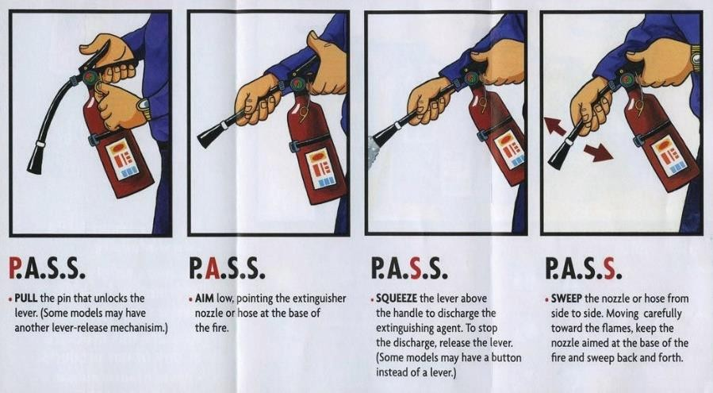

TO USE YOUR EXTINGUISHER, REMEMBER “P.A.S.S”

23

22

Unsafe Equipment
If you find a piece of plant or equipment that is unsafe in any way, please tag it out and report it at once to your Supervisor or Manager. Make sure a Hazard Identification form is completed.
For unsafe areas: Fence off area so nobody else can enter and communicate the hazard to the team.
DO NOT CONTINUE TO USE UNSAFE PLANT OR EQUIPMENT

Protective Equipment & Safety Devices
Personnel Protective Equipment (PPE) is issued to employees for specific tasks.
The equipment is a control measure to protect the user. PPE can include
clothing and safety footwear.

Hearing Protection
Although earmuffs are not required (as the noise levels are under (85dB) in the packhouse some staff may find the background noise of the machinery invasive and adding a feeling of increased fatigue. If an employee would like to wear hearing protection it is recommended that a metal detectable (blue) ear plug be used. This will breakdown background noise but not reduce the ability to hear other speak or changes to the machinery.
Ear plugs are available if requested. Contact the Health & Safety Manager.
The PPE required is documented at the start of each work instruction you have been trained on.

Footwear
All employees must wear suitable shoes or boots on site. Your footwear must cover the foot, have a good sole and ankle support. For some tasks safety footwear is required ref to the safe work instruction (SWI) for specific PPE requirements. Your Supervisor will give instructions as to the type of footwear needed for the tasks being undertaken.
24
Protective clothing will be issued on induction. Clothing is to be kept in a clean condition.
Protective clothing should not be worn off site.

If removing clothing from site to clean. The clean clothing should be returned to site in a clean bag, isolated from other clothing and food items.

Event Reporting
CAJ views safety, health and the prevention of incidents as one of the main objectives of its operation.
In the event of an incident, you must follow the steps below:

- Ensure all those requiring medical treatment are cared for.
- If necessary, seek medical help – by dialing 111.
- Ensure all other employees involved are safe
- Ensure the Manager or Supervisor is notified
- Ensure the area is secured (for a notifiable event only)
- All events, no matter how slight, must be reported immediately to your Supervisor, or Manager and an Event Report Form must be completed.
These forms are located in the site office or in the document pocket located at the H&S notice board.
- The event will then be investigated. You may be required to participate in the investigation.
- Agreed corrective actions raised are then implemented.
- All events are recorded in the Event Register and discussed at every monthly H&S meeting.
- Near hits, unsafe behaviour, and harassment can also be recorded on the Event Reporting Form.
- NOTE: Any medical treatment that is attained outside of work hours but is related to a workplace event must be reported to the Manager or Supervisor as soon as possible.
25

Operating Plant & Equipment Four rules for operating a machine Never operate a machine unless:
- You have been shown and understand how (trained)

- You are authorised (trained) to do so.

- You know how to stop it in an emergency.

- You fully understand all the safety instructions.

  - Some machines are fitted with safety guards to prevent access to moving parts. Never remove a guard or start a machine without a guard.
  - Never deactivate an electrical safety device.

  - Always keep your hands clear of moving parts.

Report any damage immediately to the Manager or Supervisor

Electrical Equipment
Only authorised tradesmen may work on electrical equipment.
  - Report any problem to the Manager or Supervisor immediately.
  - When tradesmen are working on equipment it must be isolated (switched off and tagged out).
  - Never tamper with these locks or tags.

26

Communication & Consultation Health & Safety Forum
Health and Safety forum members will be nominated every three years (or if a member does not return or resigns from the forum).
We encourage you to make constructive suggestions on ways of making your workplace safer.
Meetings are held a minimum of quarterly (every 3 months) with the Health Safety & Product Compliance Manager; any suggestions should be raised to your forum member.

Safety is like a lock, YOU are the KEY.

27

Hygiene
As a food producing company, we operate under a Ministry of Health recognised Food Safety Programme. We must maintain very high standards of cleanliness at every stage of growing, harvesting and packing our fruit.

Personal Hygiene
Good personal hygiene is critical to ensure the safety of the food is not compromised. The following guidelines have been detailed and employees made aware of these during their training.
Where a team member does not meet the strict standards of hygiene and cleanliness required, he/she will not be allowed to commence work and will be sent home without pay until they are able to present themselves to an acceptable standard.

Hand Washing
As hands are in direct contact with the apple, they are the main routes for transferring food poisoning bacteria from our bodies or from contaminated materials. You must thoroughly wash your hands and dry your hands before handling fruit.
Supplying safe food is vital to our business. Your actions are important in ensuring that this happens. (Any contaminated fruit must be isolated and disposed of immediately). Ask your Supervisor or Manager for instruction if unsure.

Contamination of Fruit

Foreign Matter
Every effort is made to eliminate the possibility of foreign matter getting into our product. Pens, pencils must only be carried in inner pockets or secured to the garment.

If any foreign matter is sighted, please remove this so it does not enter the marketplace.

Glass, Plastic & Metal
No items of glass are allowed on the property outside of the café area. This includes drink bottles and food containers.
Plastic drink bottles are to be left in lockers.

The Glass and Plastic’s policy is attached to the rear of this hand book.

Wood & Leaf
An apple should have a stem attached to the first nodule, and be clean (i.e. no leaves)
The wood after the first nodule is considered objectional matter and should be removed.
Your Supervisor will instruct you on the correct way to pack an apple.

Eating & Drinking
Must not occur in close proximity to harvested fruit. Accepted areas to eat are in the café and smoker’s area
All food wrappers and bottles are to be removed and placed in the rubbish bins located in these areas.
No food is permitted in areas.

Allergens
Allergens are proteins in certain foods that cause some people to have an allergic reaction. A food allergy is an abnormal response to a food triggered by your body’s immune system. Some foods, such as peanuts, dairy products, eggs, fish, crustacean, shellfish, tree nuts, wheat or soybeans, can cause allergic reactions in people with food allergies.
Please make sure hands are washed prior to handling produce. This is the best way to remove potential allergens.

28 29

Blood & Bodily Fluids
Any cuts and/or scratches that may result in bleeding must be covered to prevent fruit contamination.
This includes new tattoos.

If any produce comes in contact with any blood or bodily fluids, it must be isolated and destroyed. Band-aids are provided by your on-site First Aider. Ensure any scratches or cuts are covered BEFORE starting the workday, monitoring the plaster throughout the day and ensure it is accounted for at the end of your day.
For the full Blood and Bodily Fluids Policy refer to the rear of this booklet.
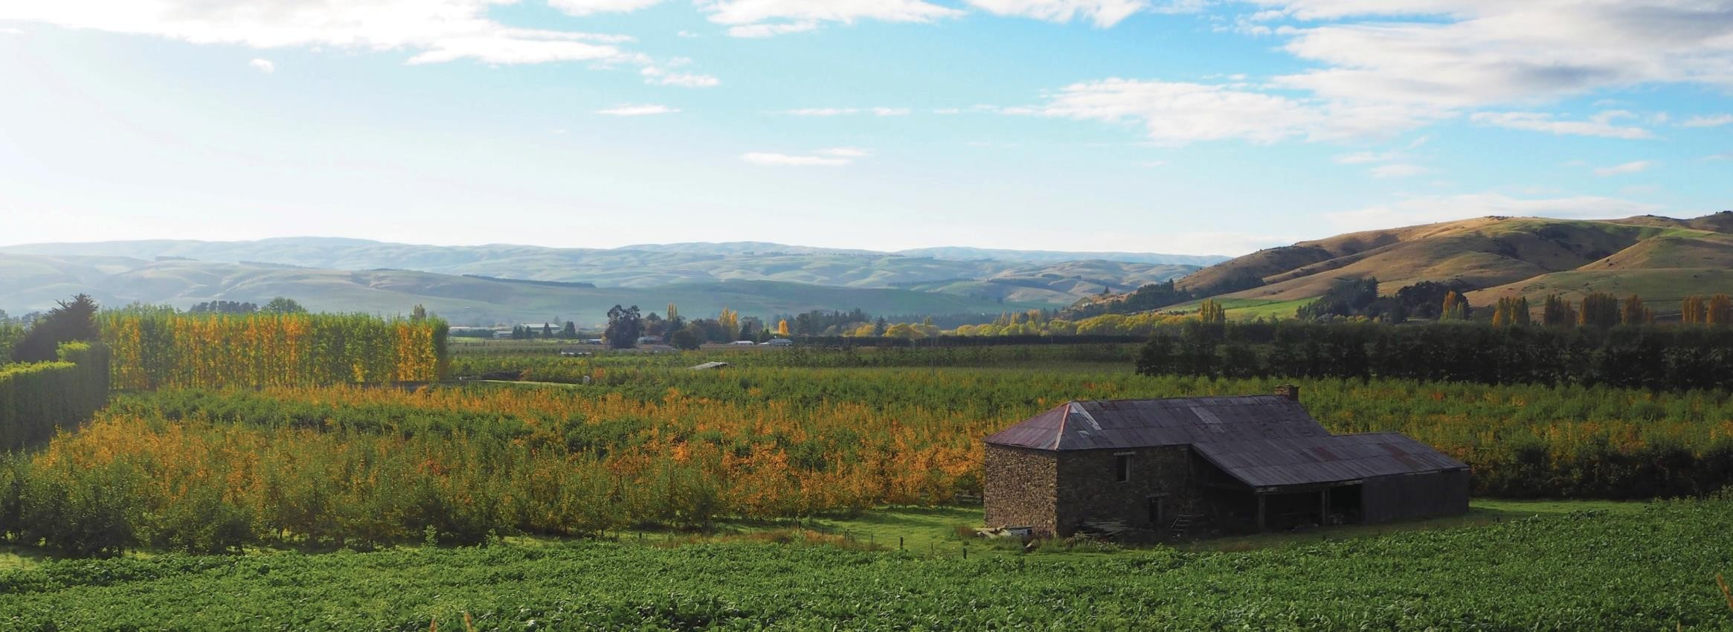
All rubbish including lunch wrappers and plastic bottles must be disposed of in rubbish drums provided, wheelie bins or taken off property at end of working day in employee’s bags.
Lines must be kept clean and tidy – all apples on the ground are placed in the bins provided at the end of the line.

30 31

Entry to the Packhouse is by authorisation only. The Main entry to the site is via the reception/cafe area. You will be asked to meet at this point on your first day. Instructions for access & parking locations will be given on induction.
Cameras
Camera’s are positioned and are used for monitoring the workplace.

Health

Sickness & Ill Health
Report ill health & sickness including cases of diarrhoea, vomiting, skin infection and flu like systems to the Manager or Supervisor.
All sickness reports are to be logged in the Sickness Register maintained by the Team Leader, Supervisor or Manager

YOU MUST NOT WORK WITH FOOD IF YOU ARE ILL!!

Infectious Diseases
Where an infectious disease may be the cause of the sickness CAJ will need a Certificate of Clearance from a Registered Medical Provider confirming the Team Member is able to handle food.
In addition, pamphlets regarding current epidemics can be found at front reception or posted in the Lunchroom. These information sheets contain formation pertaining to the symptoms, what to do if you think you may have encountered the Pathogen and who to contact.
The best from of protection is personal hygiene (hand washing and sanitisation) and sneezing into the bend of the elbow.
Medical Conditions
Employees are required to complete a Health Declaration prior to
commencement of employment and are required to notify CAJ of any relevant health conditions or infectious diseases with which they may be suffering from or have been in contact with, BEFORE starting work.
Personnel are to notify Management of any medical requirements during work hours to minimise the risk of contamination and to ensure all care is taken by CAJ to ensure your safety. E.g. lone workers.
If you are required to take medication while at work, please let your Manager or Supervisor know.

Facilities

Toilets
There are toilets provided on site, in the reception area and by the staff locker area. You will be shown their location on induction.
As we are handling fruit it is important that hands are washed thoroughly with soap and water provided after using toilet facilities.

Smoke Free & Smoking Designated Areas
We have a designated area for smoking and no smoking is allowed anywhere else onsite.
We care about our employee’s health and welfare and we want to provide a healthy and safe working environment for all.

Unauthorised Areas
The Packhouse has areas that are considered potentially hazardous, entry is by authorised personnel only. These areas include the Palletisation, Canopy, Yard and Coolstore areas - forklifts operating. Compressor Room – Noise above 85db.

32 33

Our Quality Management Programme emphasizes continuous improvement in everything we do. The company provides on the job training to assist you to develop personally and professionally.
We recognise that the success of our people and our company depends largely on training for the person’s present work and for future responsibilities. We expect you to participate in all training offered. The Manager must approve all external training.
We are committed to a policy of equal employment opportunity for all employees.

People & Performance

Health & Safety Policy
The Health and Safety Policy scopes CAJ’s commitment to ensuring the health & safety of employees. This is done by mitigating the risk to employees. The policy is posted in the Lunchroom and at Reception of the Packhouse. The full policy is attached in the Appendix of this booklet.

Continuous Improvement Policy
The Continuous Improvement Policy scopes CAJ’s commitment to the continuous improvement of our Food Safety & Quality systems, in packing fruit that meets all of our customer requirements and is of a high standard. The Policy is posted in Reception and on the Lunchroom wall. The full policy is also in the Appendix of this booklet.

Alcohol, Illegal Drugs & Solvents Policy
Alcohol is not permitted on company premises. Any person, who drinks alcohol, takes illegal drugs or solvents during working hours or reports for work under the influence of alcohol, drugs or solvents may be liable for immediate dismissal. The full policy can be is in the Appendix.

Harassment (Sexual or Racial) Policy
Employees have a responsibility to, always; maintain high standards of honesty and integrity in their conduct towards fellow staff and customers of the Employer. It is the policy of the Employer to provide a workplace free
from harassment. This extends to and includes sexual and racial harassment.

Harassment may be defined as language or behaviour either overt or implied, towards an employee, which is, and is perceived by that employee, to be objectionable or offensive.
If you are subjected to or witness any objectionable behaviour notify your Supervisor or Manager immediately.
The full policy is attached in the Appendix.

Domestic Violence
If you are a victim of domestic violence please let you manager or supervisor know CAJ will assist you in getting the help you require. CAJ will follow the requirements as set out under the Domestic Violence Act 2019. For more information see your Supervisor or Manager.

Punctuality
You are expected to be ready to start work at the correct time, observe the agreed breaks and to continue working until it is time to stop work. Please refer to your contract for further information.

Payday
Company policy is salaries and wages are paid fortnightly. If you have any questions about your pay, please see your Supervisor or Manager.

Product Removal
The removal of product from CAJ properties must be authorised by the Supervisor or Manager.

Complaints & Suggestions
CAJ is focused on continuous improvement. Complaints and suggestions can be made without being penalized and are discussed in meetings between the employee’s representative(s) and the Management team.

34 35

Professional & Personal Development Other Contact Numbers
37

Resignations
We hope that you are here to stay but if you decide to leave, notice of resignation is required as per the conditions of your Employment Agreement.

Southern Orchard & Operations Manager.
Chris Hull: 027 221 2865

Nithdale Orchard Manager.
John Tomkin: 027 255 7325

Disputes & Personal Grievances
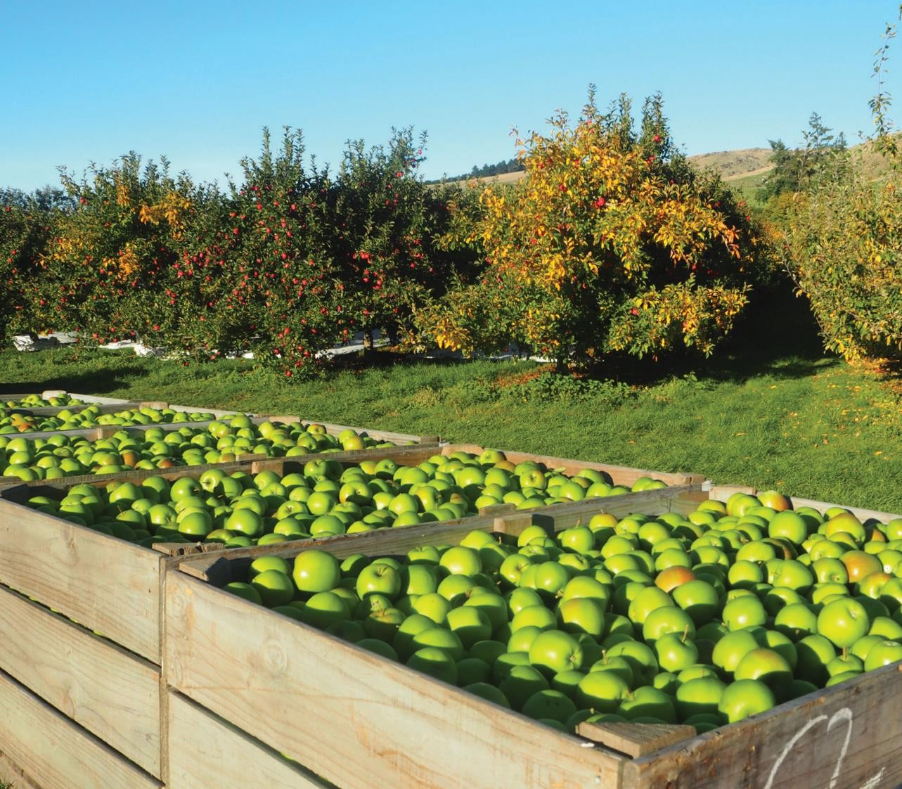
Any disputes or personal grievances should be brought to the Supervisor or Managers attention.

John McKinnel: 027 201 5140

Elderslea Orchard Manager Ross Smith: 0210605305

Roseburn Orchard Manager Hayden Taylor: 027 4698677
Hollandia & Earnscleugh Orchard Manager
Murray Booth: 027 340 1965

Toni Birtles: 021 294 1977

36

APPENDIX ONE HEALTH & SAFETY POLICY

Policy Owner & Contact: Health Safety & Product Compliance Manager

This policy applies to: All CAJ van der Voort Group (CAJ) employees, contractors, customers and visitors, both the Pack- House and Orchards
This signed policy confirms our commitment to making CAJ van der Voort workplaces a safe and healthy work environment.
DISPLAYED
This policy will be displayed at each work location within the CAJ van der Voort Group.
PURPOSE & AIM
CAJ is committed to providing a safe and healthy working environment for all people involved in our business.
This Health & Safety Policy (Policy) expresses our commitment to health and safety in the workplace.
If you work at CAJ in any capacity, including employees and contractors, whether on a full-time, part-time or casual basis, on or off-site, or if you are a customer or visitor visiting our workplace or an event we have organised, then this Policy applies to you and you must familiarise yourself with, and comply with, the current Policy.
This Policy is subject to relevant NZ legislation. This Policy may be reviewed, varied, added to or withdrawn by CAJ at any time, at our absolute discretion.
CAJ’s PLEDGE TO WORKPLACE HEALTH & SAFETY
We promote a culture which endeavours to control the risks of harm to our people at work.
To meet our commitment to workplace health & safety, CAJ takes all reasonably practicable steps to:
  - ensure workplace health and safety is implemented and maintained at any of the premises controlled by us.
  - ensure a HS Management System is implemented, that continually improves our workplace health and safety and risk management process.
  - monitor workplace conditions and identify and respond to any risks as they arise.
  - integrate health and safety into the organisations planning cycle so that measurable safety objectives and targets can be set, plans formulated, performance measured on a regular basis.
  - consult, communicate and empower employees to cultivate a positive culture of health and safety and support the active management of risks to health and safety in their own work area.
  - ensure all people, including contractors, are held accountable for fulfilling their health and safety responsibilities.
  - provide appropriate training, instruction and supervision to people regarding workplace health and safety related matters.
  - make available appropriate first aid facilities, supplies, and personnel trained to administer first aid.
  - assign resources to meet the commitments of this Policy; and
  - review and, where possible, improve policies, management systems and practices relating to health and safety.
  - Providing and maintaining a safe working environment

YOUR PLEDGE TO WORKPLACE HEALTH & SAFETY
Workplace health and safety is a joint responsibility of all persons in the CAJ workplace, and you are responsible for ensuring your own health and safety, as well as the health and safety of others.
This means you will need to:

  - work in a safe and responsible manner, and not in a way that places you or others in a position of risk to safety or health;

38 39

  - follow safe work practices and methods and abide by all applicable safe working instructions, directions and procedures;
  - wear all assigned safety clothes and equipment, where appropriate;
  - only use materials, equipment and vehicles that you have been approved to use;
  - not interfere with or misuse any plant, equipment, vehicles or any other materials provided by CAJ;
  - ensure all plant, equipment and vehicles are safe to use before operating;
  - assist in identifying and assessing risks and implementing risk control measures;
  - take reasonable steps to maintain your immediate work area in a tidy and safe condition;
  - attend regular training dealing with workplace health and safety;
  - immediately report any:
  - unsafe plant, equipment or vehicles, or working conditions or unsafe work practices you become aware of;
  - injuries or illnesses (however minor) and any ‘near misses’;
  - any breach of this Policy;
  - co-operate with CAJ regarding any workplace health and safety-related matter
CONSEQUENCES OF BREACHING THIS POLICY

CAJ retains the discretion to commence disciplinary action for breaches of this Policy.
Disciplinary action may include a written warning, counselling, suspension or the cessation of a person’s employment with CAJ.

APPENDIX TWO DRUGS AND ALCOHOL POLICY

PURPOSE OF THIS IS:

  - To show our responsibility and commitment to ensuring a safe and healthy workplace for all employees, visitors and contractors.
  - To ensure that CAJ employees can work in an environment that is free of alcohol or drug use or abuse.
  - To provide an opportunity for staff members with a substance abuse problem to get well rather than providing grounds to terminate their employment.
SCOPE:

  - This policy applies to all CAJ employees, visitors, contractors and their staff on all CAJ sites, inside and outside of normal scheduled working hours.
  - All employees are expected to be fit for duty for scheduled work and be able to perform assigned duties safely and acceptably without limitation or endangering themselves or any other person’s due to the use or after effects of alcohol, illicit drugs, non-prescription drugs or prescribed medications or any other substance.
  - There is a zero tolerance for staff who arrive at work under the influence of alcohol or drugs and/or whose ability to work is impaired in any way by the consumption of alcohol or drugs or who consume alcohol or drugs on workplaces to which they are assigned.
  - If any accident/incident is suspected to be resulting from an employee affected by alcohol, illicit drugs, non-prescription drugs or prescribed medications or any other substance, CAJ has the rights to get that employee tested immediately.
  - CAJ reserves the right to conduct searches for drugs or alcohol, including but not limited to searches of lockers, cars, bags etc which are on properties where employees are working or living.

40 41

  - Any drugs or alcohol found as a result of such a search will be fully documented and handed over to the police.
  - The occupant or user of the object searched will be subject to an internal company inquiry and may be subject to disciplinary action under CAJ code of Conduct up to and including termination of employment.
ROLES AND RESPONSIBILITIES
It is the responsibility of CAJ employees to identify concerns about any individual’s immediate ability to perform their job. Where necessary they will advise a supervisor or employer to remove any employee who is suspected of breaching this policy from their premises pending investigation and
a decision on appropriate consequences including potential disciplinary action.
Employees who are prescribed medication are expected to ask their doctor if the medication will have any potential negative effect on their job performance. They are required to report to their supervisor if there is any potential risk, limitation or restriction for whatever reason that may require modification of duties or temporary reassignment and provide appropriate medical verification on any restrictions in performance of their duties.
If an employee or contractor believes an employee in a more senior position is in violation of this policy they are encouraged to get a second opinion where possible.
CAJ will document and report any violations of this policy. Everyone has a responsibility to keep themselves safe and provide for the health and safety of those around them. Otherwise they may unwittingly contribute to the on- going health and safety concerns of an addicted individual and be a danger to those around him or her.

APPENDIX THREE HARASSMENT POLICY

All employees have a responsibility to, at all times; maintain high standards of honesty and integrity in their conduct towards fellow staff and customers of the Employer. It is the policy of the Employer to provide a workplace free from harassment. This extends to and includes sexual and racial harassment.
Harassment in the workplace may be defined as overt or implied behaviour towards an employee, which is, and is perceived by that employee, to be objectionable.
SEXUAL HARASSMENT DEFINITIONS
Sexual Harassment

- An employee is sexually harassed in his/her employment if the employer or a representative of the employer:
  - makes a request of that employee for sexual intercourse, sexual contact, or other form of sexual activity, which contains:
- an implied or overt promise of preferential treatment in that employee’s employment; or
- an implied or overt threat of detrimental treatment in that employee’s
employment; or
- an implied or overt threat about the present or future employment status of that employee; or
  - By:
- the use of words (whether written or spoken) of a sexual nature; or
- physical behaviour of a sexual nature - or subjects the employee to behaviour which is unwelcome or offensive to that employee (whether or not that is conveyed to the employer or representative) and which is either repeated or of such a significant nature that it had a detrimental effect on that employee’s employment, job performance, or job satisfaction.

42 43

Racial harassment
- An employee is racially harassed in his/her employment if the employer or a representative of the employer:
  - uses language (whether written or spoken), or visual material, or physical behaviour that directly or indirectly –
- expresses hostility against, or brings into contempt or ridicule, the employee on the ground of the race, colour, or ethnic or national origins of the employee; and
- is hurtful or offensive to the employee (whether or not that is conveyed to the employer or representative); and
- has, either by its nature or through repetition, a detrimental effect on the employee’s employment, job performance or job satisfaction.

- An employee is also racially harassed in his/her employment if the employee is subjected to behaviour of the kind described above by a person (not being a representative of the employer) who is a co- employee or who is a customer or client of the employer.
EMPLOYEE RESPONSIBILITIES
An employee who believes that he/she or some other employee is being sexually, racially or otherwise harassed must promptly report that conduct to their immediate manager.
MANAGEMENT RESPONSIBILITY
All supervisors are responsible for ensuring that no harassment occurs with- in their area of authority. All complaints will receive immediate attention and will be reported to the Management.
All supervisors will, upon the receipt of a verbal complaint of harassment encourage the employee to complete the Harassment Complaint Form

which can be sourced from the Manager. If the employee refuses the manager should record that refusal.
INVESTIGATIONS INTO ALLEGATIONS
Investigations into allegations of harassment will be conducted in a sensitive manner and to the extent possible will remain confidential. An investigation may require conferring with parties and witnesses named by the complain- ing employee. An investigation into an allegation of sexual harassment will take no account of any evidence of the sexual experience or reputation of the complaining employee.
CONSEQUENCES OF HARASSMENT
Harassment will be regarded as serious misconduct. If the investigation reveals that harassment has occurred prompt action sufficient to stop harassment, safeguard the employee and to prevent any re-occurrence will be taken. This action may include disciplinary action up to and including summary dismissal.

44 45

APPENDIX FOUR QUALITY & FOOD SAFETY POLICY
C A J van der Voort Packhouse, accepts the responsibility to implement and manage a certified quality system to ensure product quality, safety and legality. To meet all product and system specifications, that adds value to our client’s product, and also exceeds the minimum requirements of the international marketplace for which our customer’s product is represented.
STATEMENT OF INTENT
C A J van der Voort will ensure nil contamination and ensure that variation of quality is reduced. To take all reasonable precautions and exercise due diligence to avoid the commission of an offence by our company or by personnel under our control.
OBJECTIVES
- Provide a professional quality service to all of our associated clients.
- To involve people in the decision-making process in order to develop a sense of common purpose.
- To implement a comprehensive staff training programme in order to lift the individual skill levels, to meet all market/industry standards.
- C A J van der Voort Packhouse has a potential commitment to optimising the use of water and energy. Achieved through turning off power using equipment when not in use and closely monitoring water use.
- CAJ van der Voort Packhouse is endeavouring to prevent damage to the environment by sensible use of equipment and products. Identifying hazards and acting swiftly to prevent any damage.
This manual is not a replacement for all other manuals used by the industry. It is to be used in conjunction with all other industry manuals, which may include – The Exporter Specification Manuals, MPI Pest and Disease ID Manuals, Growsafe Manual and Pack House Health and Safety System.
It will be Management’s responsibility to implement the policy and achieve the objectives by putting in place systems and providing resources so that the policy can be realised.

APPENDIX FIVE GLASS & PLASTIC POLICY

Glass materials including bottles, watches, containers, thermos flasks and mirrors are banned from CAJ van der Voort’s Packhouse.
Where glass needs to be used as part of or attached to any packing area equipment or machinery it must be regularly checked to ensure it is not cracked or broken. Glass must have a protective film (to stop from shattering) or a screen erected to ensure that glass does not go onto food area if it is broken.
All staff must be informed of the Packhouse “Glass/Hard Plastic Policy” and able to act appropriately if there is any breakage. This applies to any location on site.
All employees must immediately report to management any broken or damaged glass or hard plastic.
GLASS / HARD PLASTIC BREAKAGES PROCEDURE
In instances where breakages of Glass/Hard Plastic (windows, lighting or other glass compounds) occurs, and any broken glass from processing equipment, forklift trucks which could have got into packed product must result in the line being stopped immediately and the line put on hold.

NOTE: PRODUCTION MUST STOP IMMEDIATELY

Any breakage of glass lenses in spectacles must be treated as a glass breakage incident and comply with relevant procedures.
This also applies to watch faces. It is for this reason that the wearing of watches is banned.
The use of glass bottles containing drinks is prohibited in the Packhouse area.

46 47

Action is to reject any product that may be contaminated, and a thorough search of the area made before any more produce is packed/processed.
The area and all equipment within a 10-metre radius of the breakage incident must be isolated immediately and thoroughly searched for fragments.
All remaining Glass/Plastic fragments must be removed immediately and disposed of carefully.
All materials (including any packed or partially packed product) and equipment in the quarantined area are to be thoroughly inspected and cleared for use. Any packed product found to have glass remnants must be rejected.
All shoes and clothing of staff that have potential contact with glass breakages are to be checked. If any glass at all is found clothes must be changed.
Damp cloths are to be used to wipe down all food contact surfaces and all floor areas in the quarantine area and disposed of afterwards.
All action taken following glass breakage must be fully documented and signed off by the QC Coordinator or the Health Safety & Product
Compliance Manager in order to clear the area for re-commencement of work.
CAJ-FR-11-002 Event Reporting Form to be filled in and kept in records.

APPENDIX SIX BLOOD & BODILY FLUIDS POLICY

In instances where any blood/bodily fluids are found in the packing area or packaging storage area the following actions must be followed.
- Production must stop immediately.
- All products in the immediate vicinity must be quarantined.
- Find the source of blood, stop the spread of it and treat the person immediately to ensure they are safe and the blood flow is stopped.
- Remove the person from the packing area and thoroughly inspect to ensure there is no trace of blood still on them. Any clothing that is affected must be removed, or thoroughly cleaned before returning to the packing area.
- If the patient is able to continue work with a bandage on, this must be secured with tape or gloves worn.
- All materials (including any packed or partially packed product) and equipment in quarantined area to be thoroughly inspected and cleared.
- Any product with traces of blood must be rejected and disposed of.
- Damp cloths with a food safe detergent are to be used to wipe down all food surfaces and all floor area in the quarantine area.
- Work may continue if all products are cleared and all surface areas are wiped thoroughly.
- All actions following finding blood must be fully documented and signed off by the Quality Controller to formally clear the area for re- commencement of work.

48 49

APPENDIX SEVEN BLOOD & BODILY FLUIDS EVENT FORM
Date of incident: Steps followed: Supervisor to Sign
- Source of bodily fluids found and safely treated.

- Person removed from area and first aid treatment given.

- Any bodily fluids found, clothes changed and laundered.

- All product and packaging in the immediate vicinity quarantined.

- All product, packaging and equipment inspected and cleared.

- Any packed product or packaging found with bodily fluids rejected and disposed of.

- Actions documented andfiled.

Comments:

APPENDIX EIGHT CAJ-FR-11-002 Event Report Form

This form must be completed with corrective actions and Manager’s
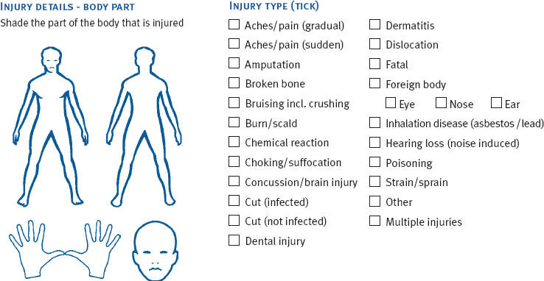
comments before returning it to Health and Safety.
e
- Person(s) Involved:  Contact No: Department: Employe RSE Worker Contractor Other (Specify):  (Including seasonal)  - Person reporting event: or Anonymous  Report: |  |  |  |  |  | 
3. Details of Event:
Location:
Time:
am / pm
Date:
Emotional or Psychological
/ / trauma
4. Event Incident |  | Near Harassment Complaint  Miss (Internal / |  |  | Product safety,  integrity, quality
Type: External) and legality.
5. Severity: Fatal Serious Harm Minor Harm No Harm Emotional/Psychological Harm
6. Treatment/Action:  Nil First Aid  Doctor What treatment was given & By Whom? |  |  | Hospital Other if other explain
7. Description of what happened or observation:

50 51

- Describe the cause and any contributory factors of the Event:

- Has a significant hazard been identified? Y / N
If yes, please investigate this hazard and update the Hazard Register in your department or section accordingly
10. Chance of the event recurring:

One off Daily Weekly Monthly 6 Monthly +
- Corrective Action: (What will be done to minimise the risk of this happening again)

By Whom Date Completed Person in control of the workplace: Name:
Signed: Position:
- Manager’s Comments:

Days off work

Name: Position: Signed: Date:

13. Health Safety & Product Compliance Managers comments:

Does this event warrant further (higher level) investigation? YES 
(complete the investigation form) NO 

13. Action taken

Accident/incident/near miss been recorded on accident register?
Y /
NHazard register updated due new hazard? Y / N
Corrective action completed? Y / N

Signed: Date:
Retain a copy for your file and give the completed original to the Health Safety & Product Compliance

52 53

Please sign this in recognition you have read and understood the contents of this handbook.
This handbook is for you to take and reference.

If you have any further queries, please do not hesitate to ask your Supervisor or Manager.
Date:
Location:
Trainer Name:
Trainee Name: | Signature

54 55

e jvandervoort@xtra.co.nz
m +64 21 431 689
a 33 Moa Flat Rd, Ettrick RD2 Roxburgh 9572
Central Otago, New Zealand NEW ZEAL AND APPLES

