Curriculum Vitae
D.O.B: 13-02-92
Address: 96 Tanner Rd
Glenleith
Dunedin
Phone: cell ph:0278410189
Name: Marina Lucy Hyndman Turnbull
Preferred name: Marina

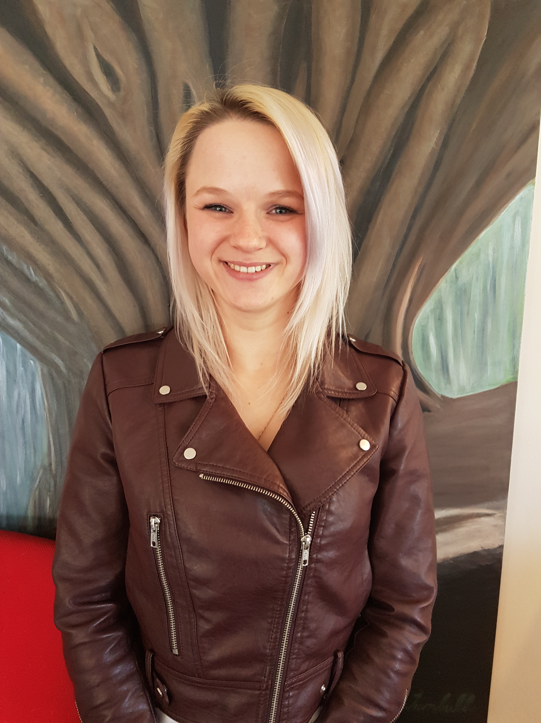

Yvette Williams Retirement Village , 13 hours per week plus on call (2018 -2021) ( Reference available)

Own cleaning business “ Let me do it cleaning Servives”
(2019-2021)
20 clients (references available)
Completed Certificate in animal care at the polytech Nov 2018
While working part time as a carer for a 30 year old man with Down’s Syndrome, and volunteering at the SPCA. (2018)

Dunedin Public Hospital, full time in the kitchen, (2014 till 2017) (reference attached)

I completed year 13 at Kavanagh College in 2010, then worked at Millbrook resort in Arrowtown, The Scenic Hotel in Dunedin cleaning in the house keeping department, and Farry’s Motels in Dunedin also in the cleaning Dept.
I have had casual work as a waitress at Good Oil ,Good Earth and Ironic Cafés.

I am strong fit, healthy , very reliable , conscientious and hard working.
I also have a good work ethic, willing to give anything a go.
I love animals and my dream is to do vet nursing or work with animals in some capacity.

Qualifications:
Level 3 Certificate in Animal Care
Level 2 NCEA- Passed
Level 1 NCEA- Passed
- NZQA Unit Standard 167 level 2- Practice food safety methods in food business
- NZQA Unit Standard 17285 level 2- Barista course demonstrate knowledge of Expresso coffee equipment and recipes.
- NZQA Unit Standard 6400,6401 and 6402- Comprehensive First Aid Course done through Red Cross. Valid till 10 Sept 2011.

Full driving license

Previous work experience:

- Kitchen assistant at Dunedin Public Hospital
- Farry’s Motel casual cleaner
- Ironic café casual waitress
- Good Oil café casual waitress
- Scenic Hotel cleaner for 18 months
- Millbrook Resort during summer holidays for 5 months from Nov 2010 till March 2011 in housekeeping department.
- Millbrook Resort during summer holidays for 3 months from Nov 2009 till Jan 2010, in house keeping department. (Written reference
Activities:
I trained as a gymnast to level 8, the top level was level 10. I represented Otago at National competitions for 2 years in Auckland and Nelson.

